JETS FAIR 2012 SENIOR BIOLOGY PRACTICAL
ADVANCE INFORMATION: The chicken Heart to be used as Specimen Q per station.
QUESTION 1.
You are provided with a specimen Q, an organ from a bird. Make a large diagram and label the positions of the four chambers.
- Calculate the magnification of the drawing.
- The muscle of specimen Q is myogenic in nature. Explain what myogenic nature of the muscle means.
Ans: The stimulus for muscle contraction originates from the muscle of specimen Q
itself and not from the brain
- Name the membrane that surrounds the specimen given.
Ans: Pericardium membrane.
- What is the fluid that reduces friction between specimen Q and the walls of the organism’s body?
Ans: Pericardium fluid.
- The beating of specimen Q is controlled by the Sino-Atrial Node and conducting systems. State the fibres that transmit impulses downwards to the base of the heart.
Ans: Bundle of His and Purkynefibres.
ADVANCE INFORMATION FOR PRACT QUESTION 2
Instructions : Each candidate must be provided with the under listed specimens:
1 .Specimens ( parts of a mouse , stomach, duodenum and ileum
2. Scapel or razor blade
3. 14 test tubes
4 .pH PAPER
5 .pH colour chart
6. Water bath ( boiling water)
7. Saline solution
8. Motor and pestel
QUESTION 2
You are provided with parts of the gut of specimen G1. Grind each tissue in 5cm³ saline.

- Using the pH paper, determine the pH of the Stomach, Duodenum and Ileum. Record your results in the table below.

REGION | OBSERVATION | pH RANGE | CONCLUSION
STOMACH
DUODENUM
ILEUM

[3]

- Use the extract formed from each region in the above test and divide volume of each into 2 test tubes labelled P and Q. Boil each content put in test tube Q for 15 minutes in the water bath. On each test tube labelled P and Q carryout the following tests;

- Protease test-;
- Invertase -;
- Amylase.

REGION |  | TEST METHOD | OBSERVATION | CONCLUSION
STOMACH | P
 | Q
DUODENUM | P
 | Q
ILEUM | P
 | Q

[6]
- What are the effects of boiling contents in test tube Q.
.
………………………………………………………………………………………………………………………………………………………………………………………………………………………………………………….. [1]
QUESTION 3.
You are provided with the following materials-:

- A graduated capillary tube
- A 500ml beaker
- Source of water and sand.

Set the experiment as shown in the diagram below and observe for 5 minutes.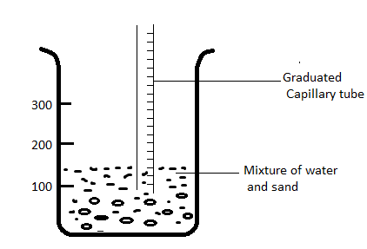
- State your observations………………………………………………….
……………………………………………………………………[1]

- Which property of water accounts for your observation(s) ? ……………………………………………………………………[1]
- What is the significance of the property stated in (1b) to plants?
……………………………………………………………………[1]
- Why did water go up instead of going down ? ……………..................................................................................[1]
3 (a) Which internal part of the plant is related to the capillary tube?
(b) What process in plants is similar to the overflowing of water from the capillary tube?
( c ) Explain four (4) significant roles played by the process mentioned in
( 3 b) to plants ?

( d) What are the three (3) types of processes mentioned in 2b?

Solutions for Question 3
3 (i) (a) Water starts going upward in the capillary tube
(b) Capillarity/ Ability to wet
( c) Helps the up take of water through xylem
( d) Due to the adhesive and cohesive forces
(ii) (a) Xylem
(b) Transpiration
( c ) –Cooling effects
-Transpiration of materials
- Maintanane of cell turgidity
- Removal of excess water

( d) – Stomata
-Venticular
-Carticular

